Winners of the Texas Cheerleader Magazine Team Excellence Award, Small Gym Program Award, the Judges Choice Award, the Small Gym Sweep Award 2012-2017, 2016 NCA PREP NATIONAL CHAMPIONS & THE ONE CHAMPIONS, and the IEP I-AWARD RECIPIENT
Over 150 National Championships and Counting…
TEXAS THUNDER



Training Champions For Life… 21 years and counting

ALL-STAR

CHEERLEADING
At TX THUNDER, we are not a one size fits all gym. We PRIDE ourselves on 21 years of 1 owner, 1 gym where everyone is FAMILY!
Hear the Thunder-Feel the Reign!

EVALUATIONS

Monday, April 24th:

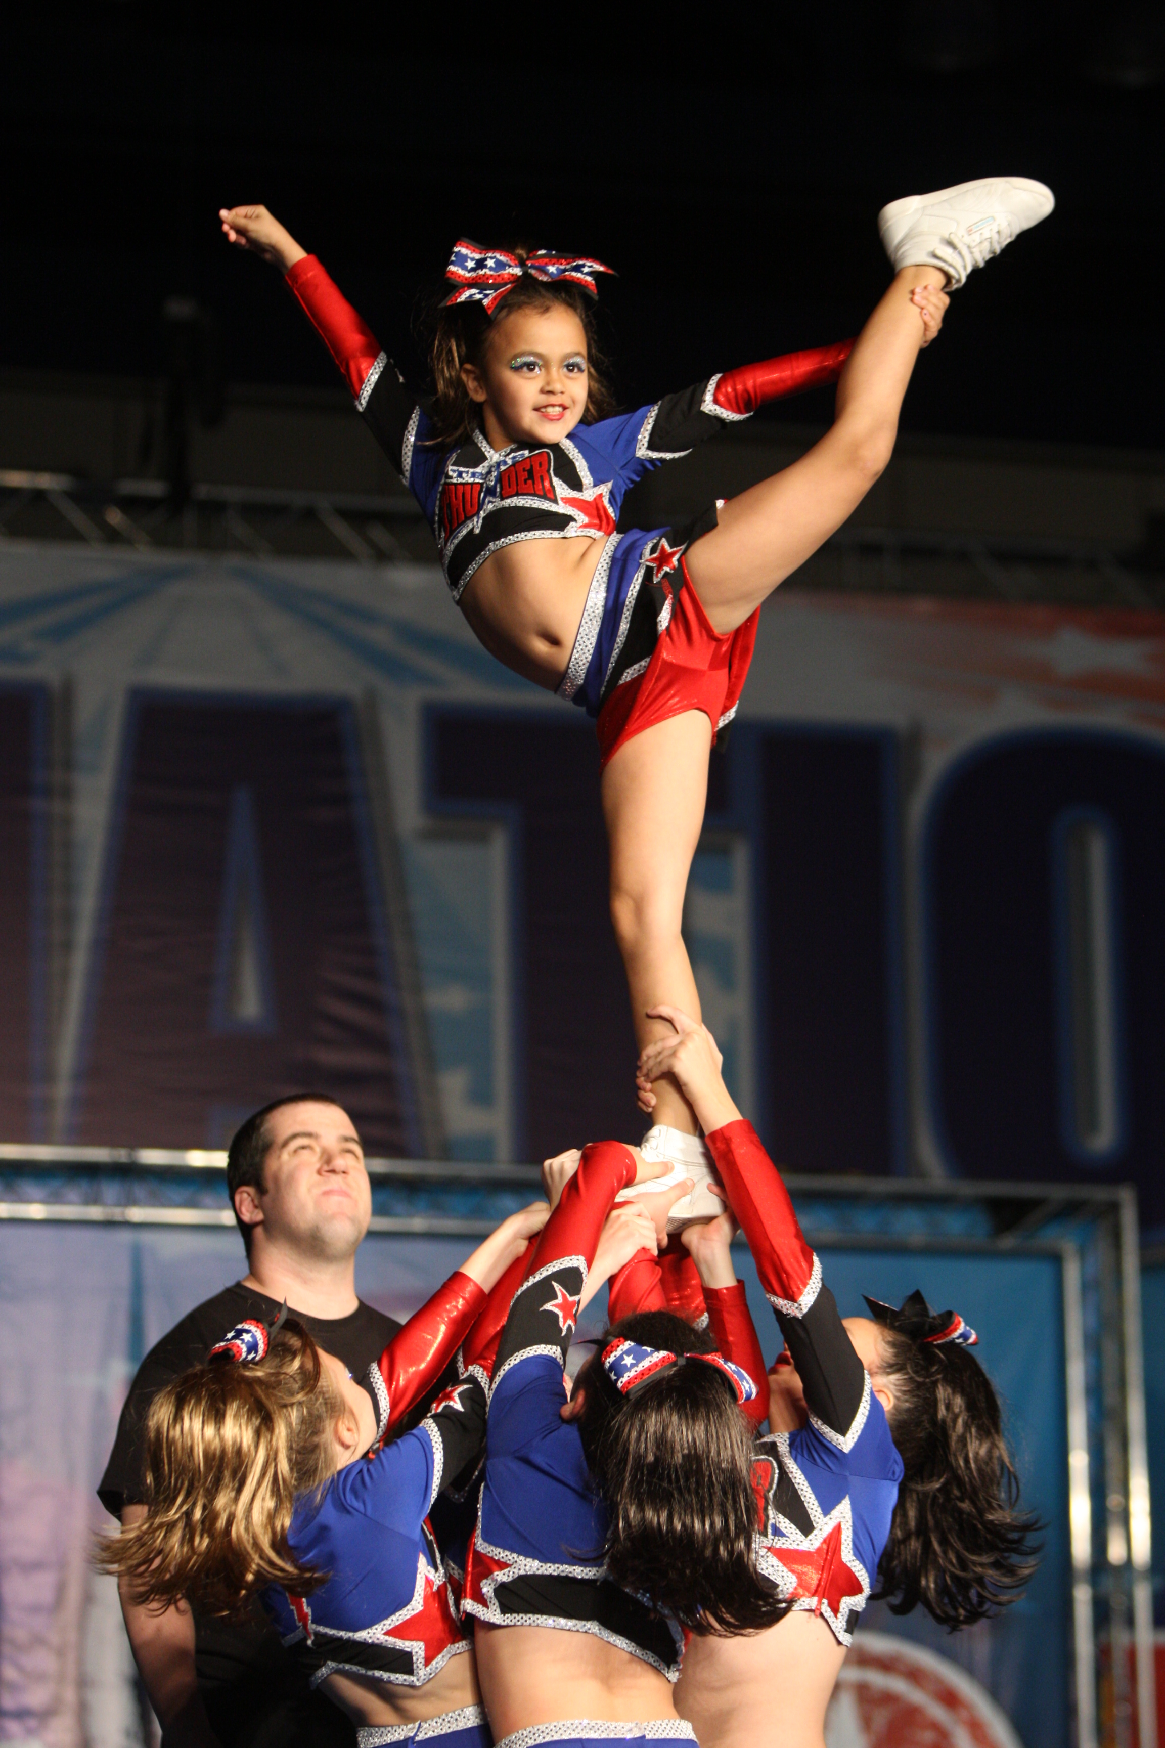
Ages 6-9: 5:00-6:30pm *Level 2*
Ages 11-18: 6:15-7:15pm *Levels 1*

All Ages: 7:00-9:00pm *Level 4/5*

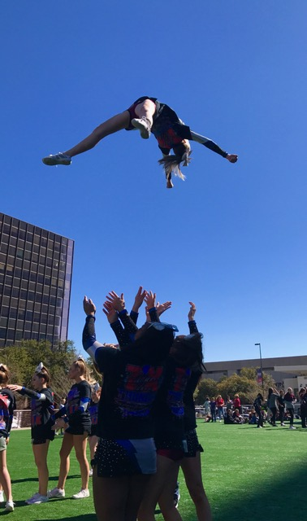
*by appointment only

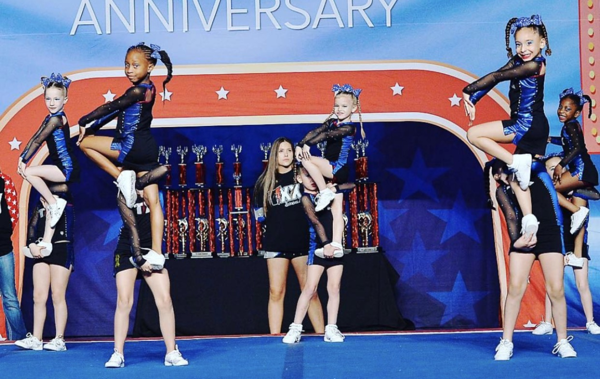
Tuesday, April 25th:
Ages 6-10: 5:00-6:00pm *Level 1*
Ages 9-11: 6:00-7:30pm *Level 2/3*

Ages 11up: 7:15-9:00pm *Level 2/3*
*by appointment only
Wednesday, April 26th:
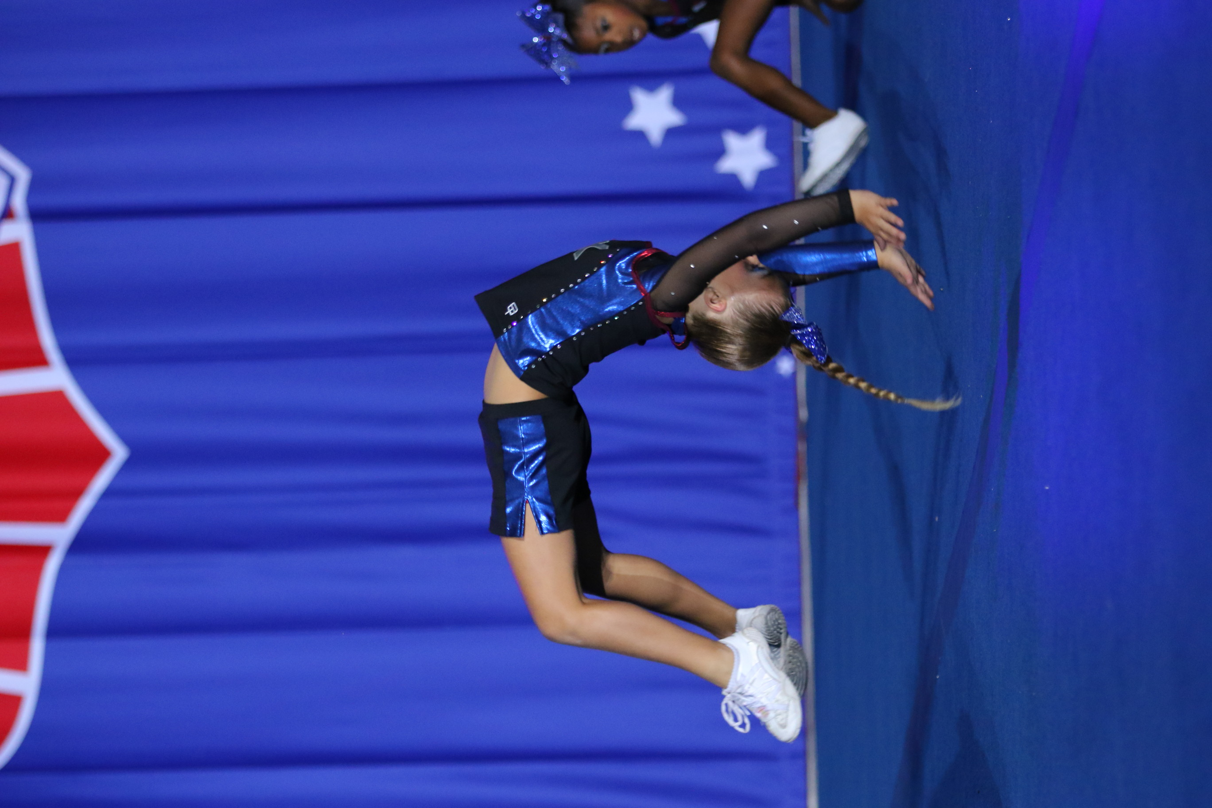
Ages 6-9: 5:00-6:30pm *Level 2* *by appointment only
Ages 11up: 6:00-7:30pm *Levels 2/3*

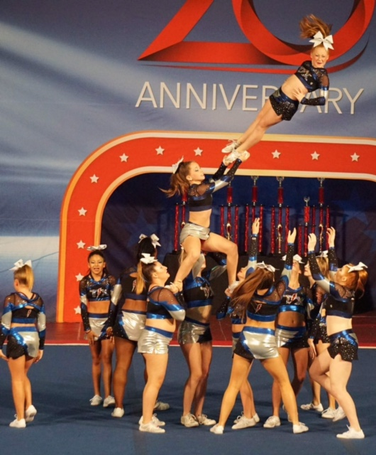
All Ages: 7:15-9:00pm *Level 4/5*

Thursday, April 27th:
Ages 6-10: 5:00-6:00pm *Level 1*
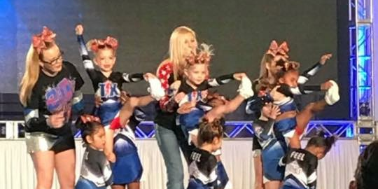
Ages 9-11: 6:00-8:00pm *Level 2/3*

Ages 11-18: 8:00-9:00pm *Level 1*
*by appointment only
Friday, April 28th:
Ages 4-5: 5:00-6:30pm *Level 1*
**If you are unable to come during these times,
please call to schedule an appointment!

**THE ANNUAL REGISTRATION FEE ($65.00)
***OPEN WORKOUTS***
Beginner Ages 6-10 Tuesdays or Thursdays 5-6
Beginner Ages 11-18 Mondays 6:15-7:15
Level 2 Ages 6-9 Mondays
Level 2/3 Ages 9-11 Tuesdays 6-7:30
Level 2/3 Ages 11-18 Wednesdays 6-7:30
Level 4/5 All Ages Wednesdays 7:15-9:00
**Come during one of these times to try one FREE CLASS!!! Additional classes are only $10.00
*starting April 10th*

IS DUE AT THE TIME OF EVALUATION!!
*Teams for all ages and abilities*
Exhibition teams & All-Star Prep Teams available
Call Today to Get a FREE CLASS in March!

(281) 232-3320

WWW.CHEERGYM.COM

Email:coachstephanie@cheergym.com
FaceBook: Texas Thunder All-Star Cheerleading
@CheergymThunder

