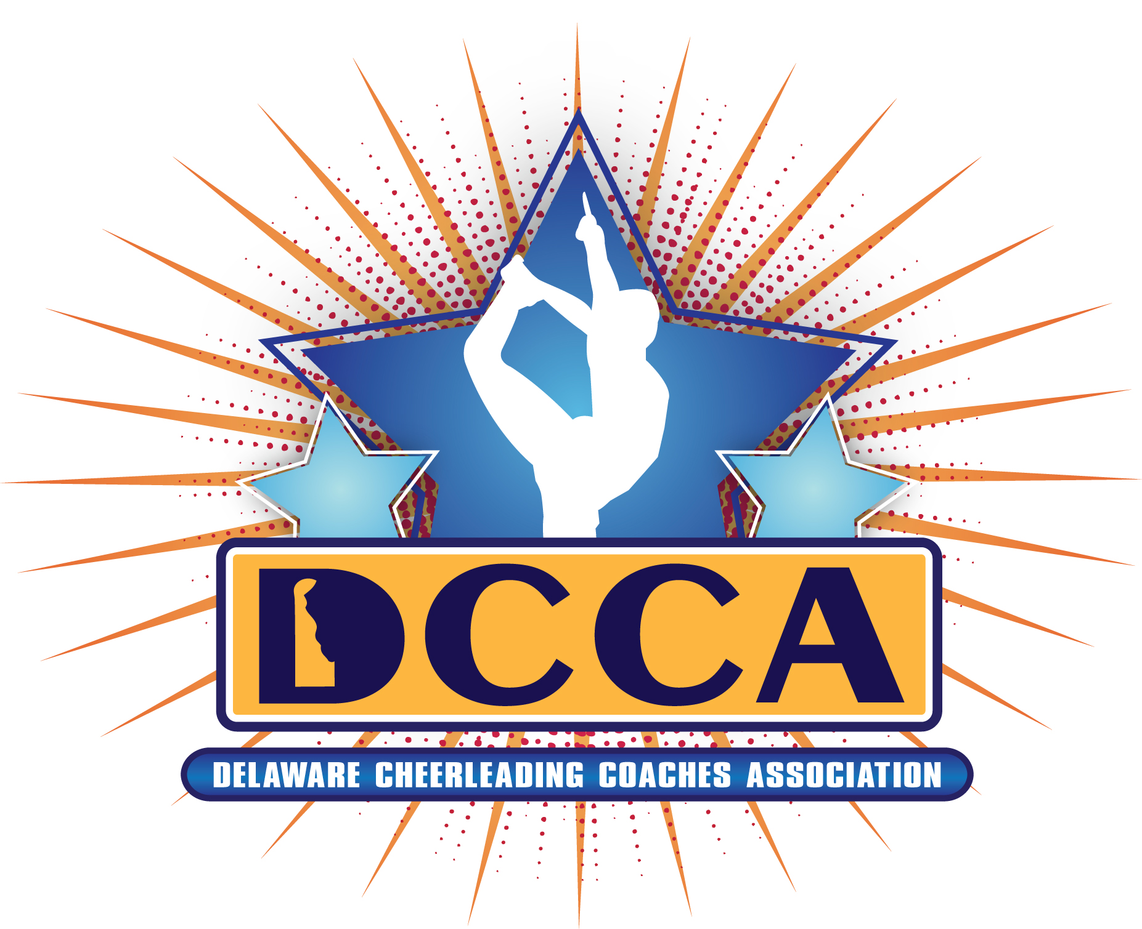

2013/2014 DCCA Membership Form
(Dues for October 1, 2013 - September 30, 2014)

Full membership: $50.00 New (limit 2); each additional coach $20.00
$40.00 Renewal (limit 2); each additional coach $20.00
Eligible: current cheer program affiliation; includes full voting privileges.

Individual membership: $20.00 New/Renewal
Eligible: any member without a current cheer program affiliation; includes full voting privileges.

Payments should be received on or before November 1, 2013.
Payments not received by November 1, 2013 will result in loss of voting privileges until the dues are paid in full. A late fee of $10 per coach will be assessed if membership payment is not received by January 1, 2014.

Please return the portion below with your payment to: DCCA c/o Jack Speakman
PO Box 30618
Wilmington, DE 19805

Registration must include name, address, email and phone number for each of the coaches you are registering for your organization. Registrations will be returned if all necessary information is not complete.

Name of School/Organization/Individual_______________________________ # of Coaches:_______

Type of Program (circle): CYM Rec. League High/Middle School All-Star Collegiate Other:

Name of Member:
Type of Membership (circle): Full Individual Please check: □ New □ Renewal
Address:________________________________________ _________________ _____
City/ State/Zip: _________________
Phone:__________________________________Email:______________________________________

Name of Member:
Type of Membership (circle): Full Individual Please check: □ New □ Renewal
Address:________________________________________ _________________ _____
City/ State/Zip: _________________
Phone:__________________________________Email:_____________________________________

2013/2014 DCCA Membership Form
Page 2 of 2

Name of Member:
Type of Membership (circle): Full Individual Please check: □ New □ Renewal
Address:________________________________________ _________________ _____
City/ State/Zip: _________________
Phone:__________________________________Email:_____________________________________

Name of Member:
Type of Membership (circle): Full Individual Please check: □ New □ Renewal
Address:________________________________________ _________________ _____
City/ State/Zip: _________________
Phone:__________________________________Email:_____________________________________

Name of Member:
Type of Membership (circle): Full Individual Please check: □ New □ Renewal
Address:________________________________________ _________________ _____
City/ State/Zip: _________________
Phone:__________________________________Email:_____________________________________

Name of Member:
Type of Membership (circle): Full Individual Please check: □ New □ Renewal
Address:________________________________________ _________________ _____
City/ State/Zip: _________________
Phone:__________________________________Email:_____________________________________

Name of Member:
Type of Membership (circle): Full Individual Please check: □ New □ Renewal
Address:________________________________________ _________________ _____
City/ State/Zip: _________________
Phone:__________________________________Email:_____________________________________

